EYFS Long Term Plan
Cycle B 2025-2026
 | Autumn 1 | Autumn 2 | Spring 1 | Spring 2 | Summer 1 | Summer 2
Themes | Marvellous Me!  Talk about themselves and their family. Who do they live with? What does their house look like? Do they have any pets? | Dark Days and Cosy Nights!  Discuss the days getting shorter and what some animals do over winter | Dinosaur Detectives  Go back in time and learn all about dinosaurs | Once upon a time!  Read familiar traditional tales. Discuss settings, characters and events that occur in the book | How does a garden grow?  Learn about how to keep plants healthy, plant seeds and observe them grow. | Down on the farm  Learn all about animals on the farm, looking at lifecycles of a chick
Possible Core Text (Linked to topic)  (* these are adapted and added to depending on different lines of interest during the half term) | 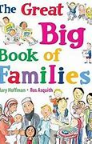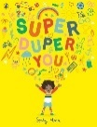 | 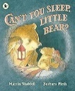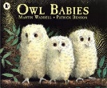 | 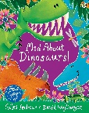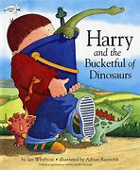 | 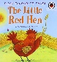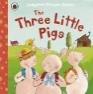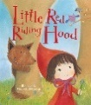 | 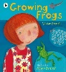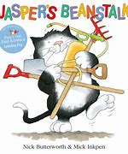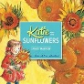 | 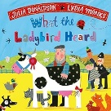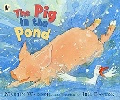
Possible Enrichment Activities / Key Experiences | Home Corner Role Play  Meet our new friends and teachers  Seasons: Autumn | Bear Cave Role Play  Seasons: Winter  Nativity  Christmas Celebrations | Dinosaur museum role play | Seasons: Spring | Garden Centre Role Play  Tadpoles  Planting seeds  Vincent Van Gogh Sunflowers | Hall Hill Farm Trip  Seasons: Summer
Seasonal Learning Opportunities / Celebrations | Halloween  Harvest - visit Escomb Church  Autumn Nature Walk | Bonfire Night  Diwali  Remembrance Day Christmas  Winter Walk | Chinese New Year  Valentine’s Day | Mother’s Day  Easter  Shrove Tuesday  Spring Nature Walk | Sun safety | Father’s Day  Summer Time Transition to Y1
Possible Texts (linked to celebrations | 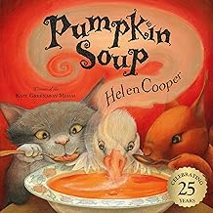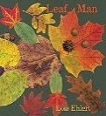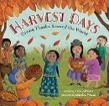 | 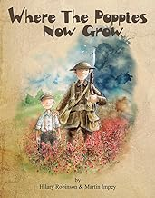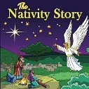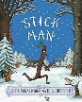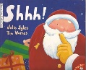 | 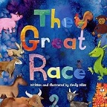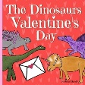 | 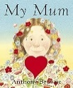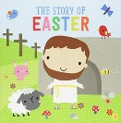 |  | 